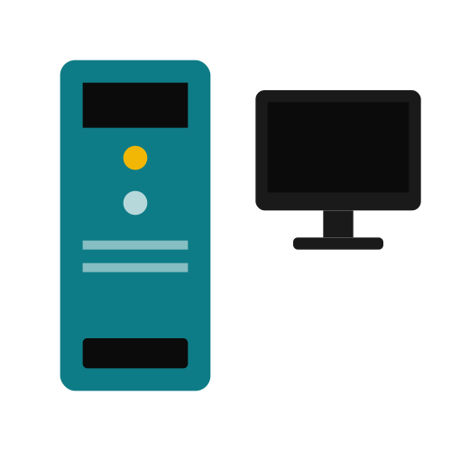
TECHNICAL DOCUMENTATION
Diagnosing and Resolving a Desktop Computer
Black Screen Boot Failure

ICT Student, Nifas Silk Polytechnic College

Addis Ababa, Ethiopia
Document Type: Hardware Troubleshooting Procedure

Group Member
- Gezahagn Tamru
- Hawi Kebede
- Blen Kassahun
- Marken Ketema
- Matyas Abreham

Sub.to: Serkie
Date: June 30, 2026

Table of Contents
Table of Contents 2
1. Introduction 3
2. Problem Statement 3
2.1 Scope 3
3. Possible Causes 3
4. Tools and Materials Required 4
5. Diagnostic and Repair Procedure 4
6. Verification 6
7. Preventive Recommendations 6
8. Conclusion 6

1. Introduction
This document provides a structured technical procedure for diagnosing and resolving a common hardware fault: a desktop computer that does not start properly and displays a black screen after the power button is pressed. A black screen on startup is one of the most frequent issues reported in desktop support, and it can result from a wide range of causes spanning power delivery, memory, display output, and motherboard components.
The purpose of this documentation is to guide a technician through a logical, step-by-step diagnostic process that isolates the root cause efficiently, minimizes unnecessary part replacement, and restores the system to normal operation. The procedures described follow standard hardware troubleshooting practice, working from the simplest and most common causes toward more complex internal checks.

2. Problem Statement
Symptom reported: Upon pressing the power button, the desktop computer either fails to display any output on the monitor or appears to power on (fans spin, lights activate) but the screen remains completely black, with no BIOS/UEFI splash screen or operating system boot sequence visible.

2.1 Scope
This procedure applies to a standard desktop tower (not laptops or all-in-one units) and covers checks that do not require specialized diagnostic equipment beyond basic hand tools and, where available, spare components for swap testing.

3. Possible Causes
Before beginning the procedure, it is useful to understand the most likely sources of the fault, ranked by how frequently they occur in real-world support cases:
Possible Cause | Likelihood | Typical Symptom
Loose or faulty cable connections | High | No display, but power LED on
Improperly seated RAM | High | Repeated short beeps, no boot
Faulty or loose graphics card | Medium | No POST beep, no display
Monitor or video cable failure | Medium | Power on normally, screen stays black
Corrupted BIOS/UEFI settings | Medium | System powers on but hangs before display
Power supply unit (PSU) failure | Low | No power LED, no fan spin, completely dead
Motherboard failure | Low | No beep, no fan response, no lights

4. Tools and Materials Required
The checks below require only basic hand tools and, where available, spare parts for swap testing.
  Phillips-head screwdriver |   Anti-static wrist strap |   Spare monitor & video cable
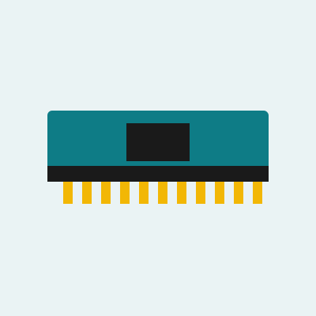  Spare / known-good RAM stick |   Compressed air / soft brush |   Notepad to log each step

5. Diagnostic and Repair Procedure
Follow the steps below in order. Each step should be completed and its outcome recorded before moving to the next, since later steps assume earlier checks have already ruled out simpler causes. Always power off and unplug the unit before opening the case or handling internal components.
Step | Action | Expected Outcome
1 | Check all power connections (wall outlet, PSU cable, monitor cable) and confirm the power LED on the case is lit. | Confirms whether the unit is receiving power.
2 | Listen for POST beep codes and observe case/CPU fan activity on power-on. | Indicates whether the motherboard is initializing (POST).
3 | Disconnect the monitor cable and reconnect it firmly, or test with a different cable/monitor. | Rules out a faulty display cable or monitor.
4 | If using a discrete GPU, reseat it in the PCIe slot, or test using the motherboard's onboard video port instead. | Identifies a failed or poorly seated graphics card.
5 | Open the case and reseat the RAM modules; test with a single stick in different slots. | Rules out memory seating issues, a common black-screen cause.
6 | Inspect the motherboard for swollen capacitors, burnt components, or disconnected CPU power (4/8-pin) cable. | Identifies visible hardware failure.
7 | Clear CMOS by removing the battery for 5 minutes or using the CMOS reset jumper. | Resets corrupted BIOS/UEFI settings that may block boot.
8 | If the system powers on but shows no display, test with minimal hardware (CPU, one RAM stick, no extra peripherals). | Isolates a faulty non-essential component.

6. Verification
After completing the relevant steps above, power the system on and confirm the following before considering the issue resolved:
- The power LED and case/CPU fans activate normally on power-on.
- One or more POST beep codes are heard, or the motherboard's onboard diagnostic LEDs/display show a normal POST sequence.
- The monitor receives a signal and displays the manufacturer splash screen or BIOS/UEFI setup screen.
- The operating system proceeds to boot normally without errors.
- The system is tested through at least one full shutdown and restart cycle to confirm the fix is stable.

7. Preventive Recommendations
- Ensure adequate case ventilation and clean dust from fans and heatsinks every few months.
- Use a surge protector or UPS to protect against power fluctuations that can damage the PSU or motherboard.
- Periodically check that internal cables (power, SATA, GPU) remain firmly seated, especially after moving the unit.
- Keep BIOS/UEFI firmware updated to the latest stable version recommended by the motherboard manufacturer.

8. Conclusion
A black screen on startup is rarely caused by a single point of failure; it is best resolved through a methodical process of elimination that starts with the simplest, most common causes (cables, RAM seating, display connections) before moving to more invasive checks (CMOS reset, component swapping). Following the procedure documented above allows a technician to identify the root cause with minimal guesswork and restore the system to a stable, working condition while documenting each step for future reference.

